# Question #5

## Extended Kalman Filter (EKF)

…

## Tuning Approach

…

## Typical Simulation Plots









## Chi-Square Test Results





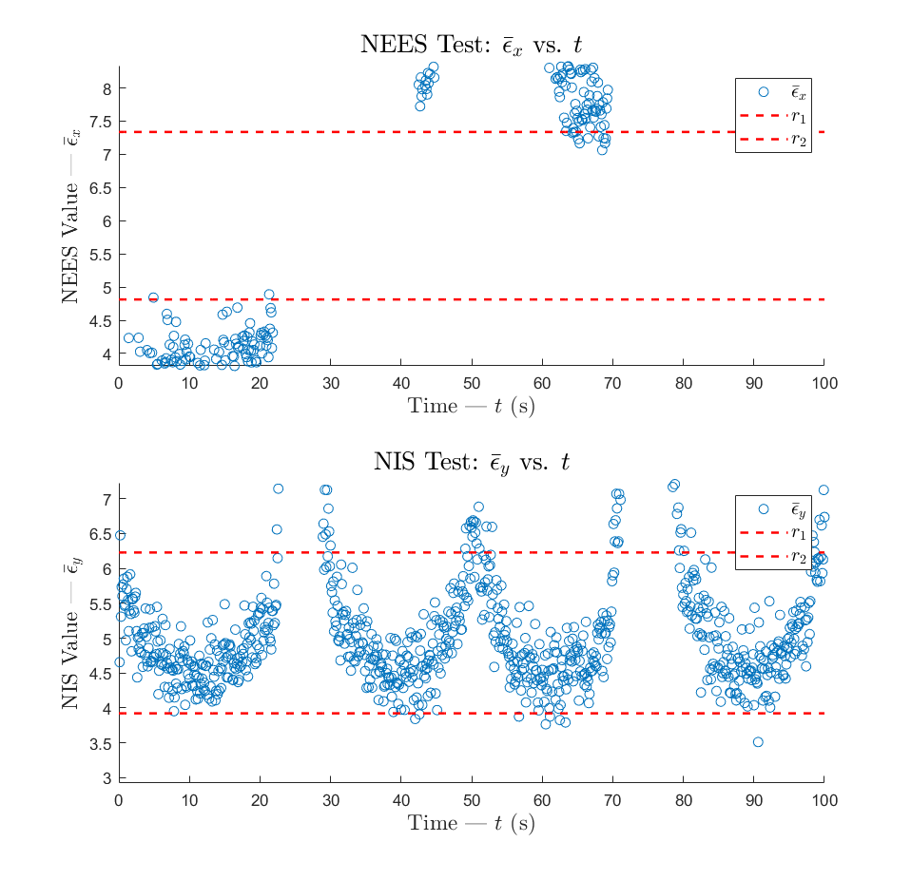

Figure 1 – NEES and NIS chi-square test for LKF Monte Carlo runs with Equations ( 3 )( 4 )( 5 ) applied

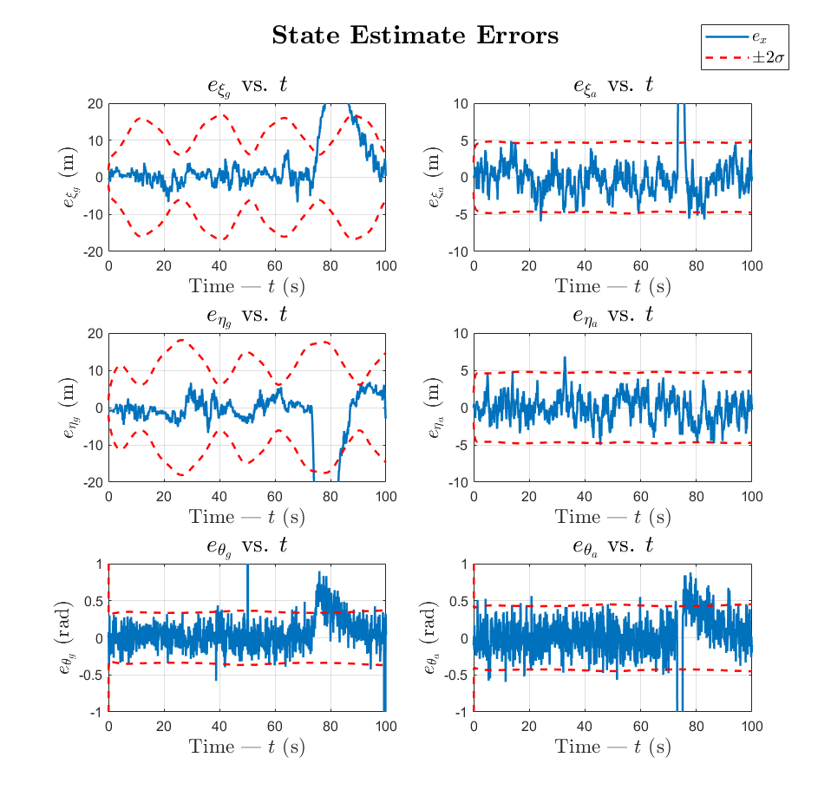

Figure 2 – State estimate errors and bounds of sample LKF Monte Carlo run with Equations ( 3 )( 4 )( 5 ) applied

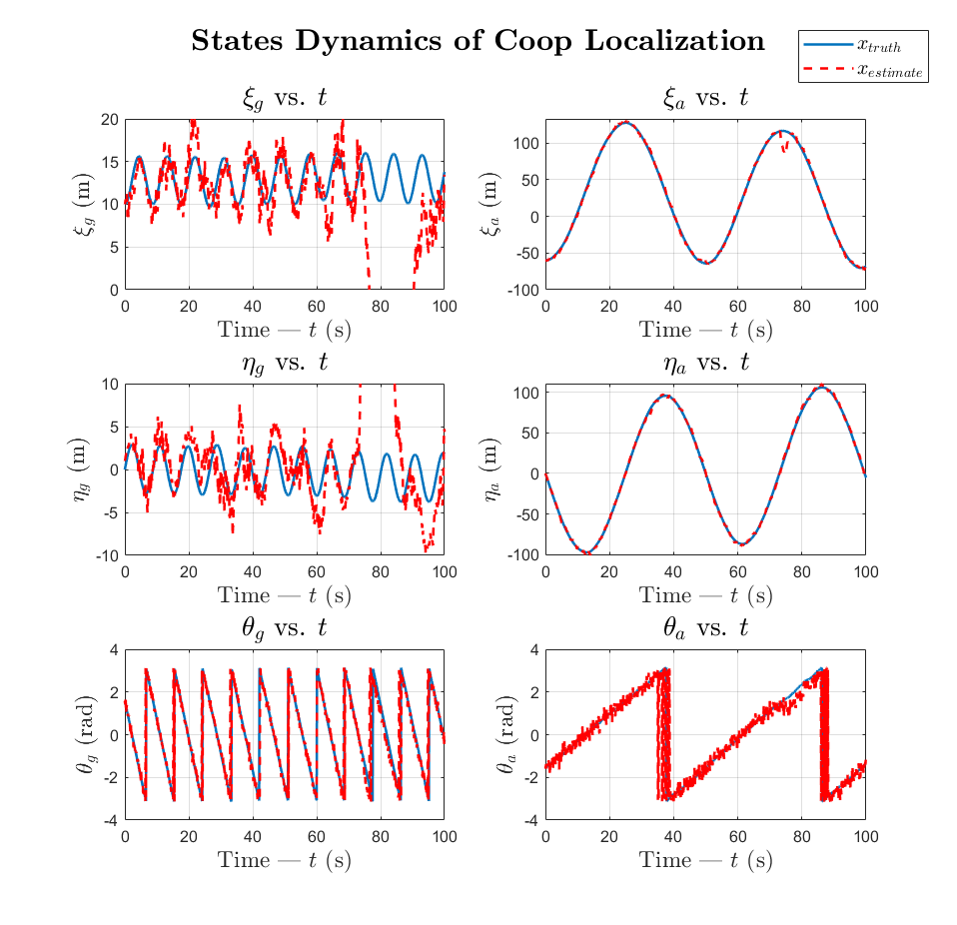

Figure 3 – State estimates and state ground truth of sample LKF Monte Carlo run with Equations ( 3 )( 4 )( 5 ) applied